Small Circle
# Source: AI Source: Provided by: [Data Path: Persons Table -> ID Column: 1, Name_En Column: Motasem Essam] -> From: [ChatGPT] on [7/25/2026]
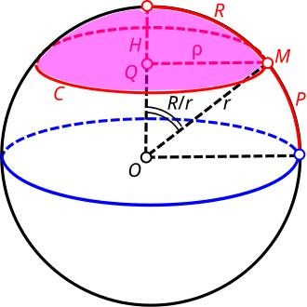
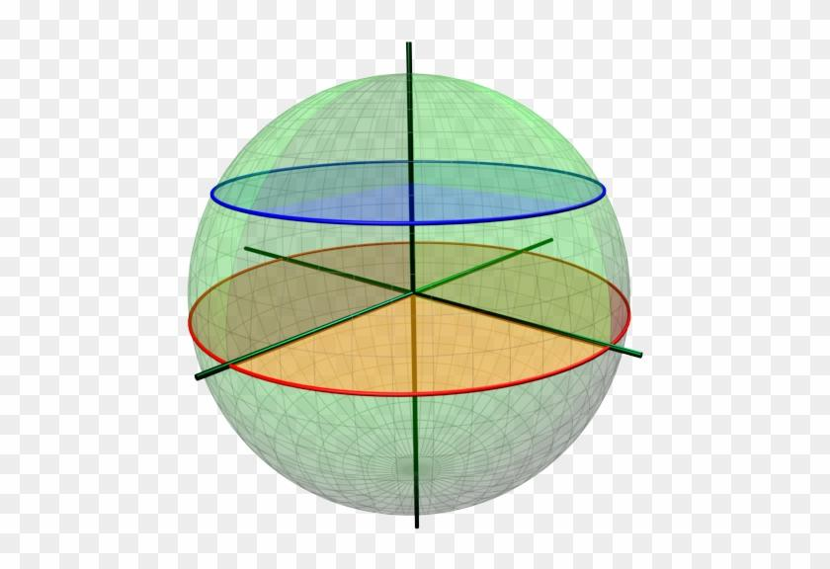
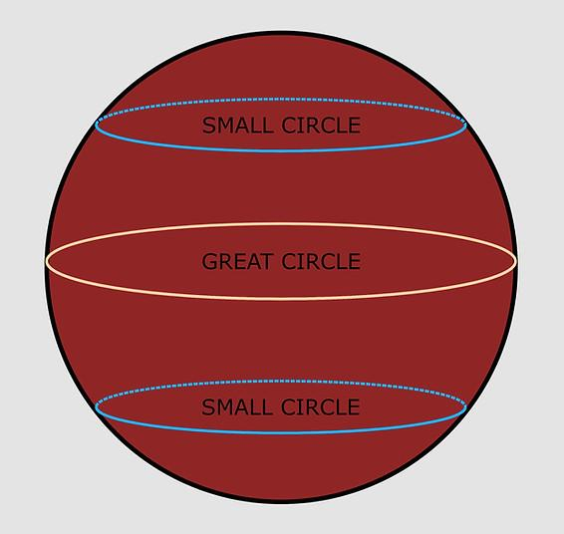

Definition
# Source: AI Source: Provided by: [Data Path: Persons Table -> ID Column: 1, Name_En Column: Motasem Essam] -> From: [ChatGPT] on [7/25/2026]
A small circle is a circle formed by the intersection of a sphere with a plane that does not pass through the sphere's center.
The radius of a small circle is less than the radius of the sphere. Its size depends on the perpendicular distance between the sphere's center and the intersecting plane.
On Earth, lines of latitude other than the equator are examples of small circles.

Simple Definition
# Source: AI Source: Provided by: [Data Path: Persons Table -> ID Column: 1, Name_En Column: Motasem Essam] -> From: [ChatGPT] on [7/25/2026]
A small circle is a circle formed by slicing a sphere with a plane away from its center.
Unlike a great circle, a small circle does not divide the sphere into two equal hemispheres.

Types of Small Circles
# Source: AI Source: Provided by: [Data Path: Persons Table -> ID Column: 1, Name_En Column: Motasem Essam] -> From: [ChatGPT] on [7/25/2026]
Small circles can be classified by the position of their cutting planes relative to the sphere's center and a chosen axis.
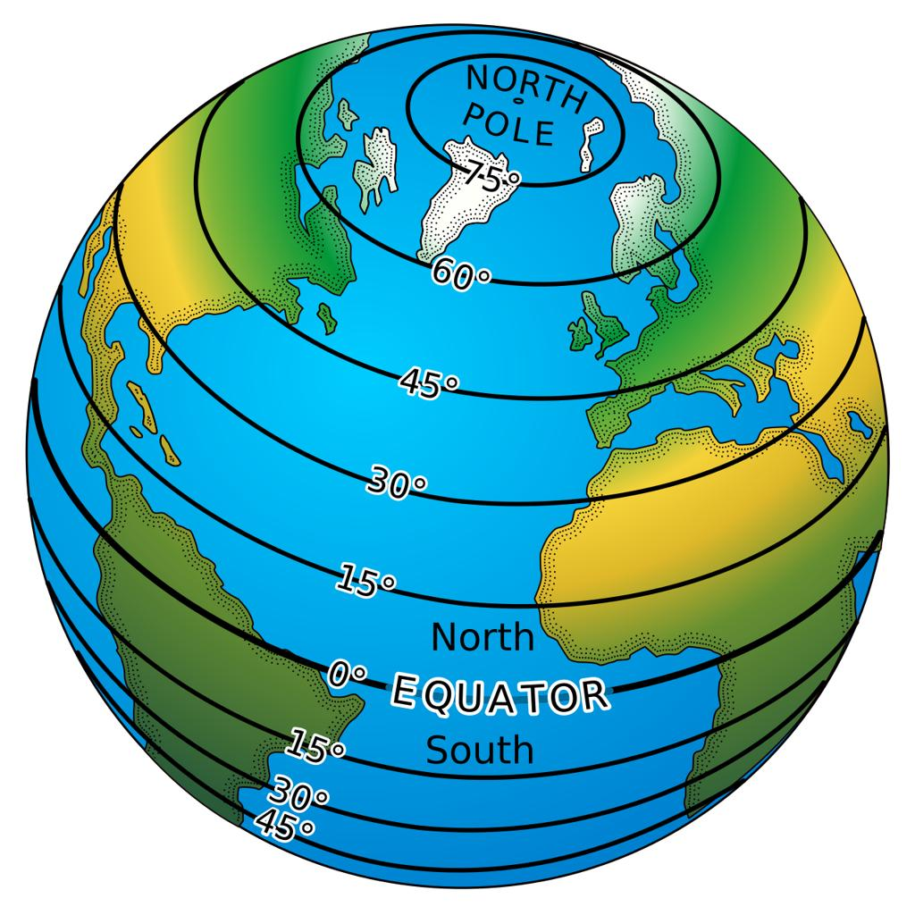

Northern Small Circle
# Source: AI Source: Provided by: [Data Path: Persons Table -> ID Column: 1, Name_En Column: Motasem Essam] -> From: [ChatGPT] on [7/25/2026]
A small circle located above the equatorial plane when the sphere is oriented with a vertical polar axis. On Earth, northern lines of latitude other than the equator are examples.
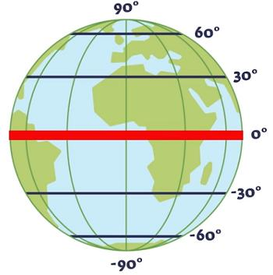

Southern Small Circle
# Source: AI Source: Provided by: [Data Path: Persons Table -> ID Column: 1, Name_En Column: Motasem Essam] -> From: [ChatGPT] on [7/25/2026]
A small circle located below the equatorial plane. Southern lines of latitude other than the equator provide examples on Earth.
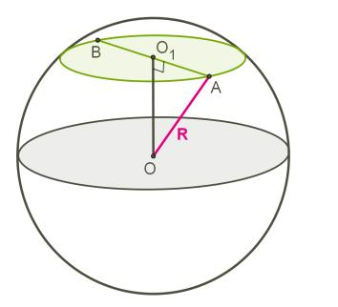

Polar Small Circle
# Source: AI Source: Provided by: [Data Path: Persons Table -> ID Column: 1, Name_En Column: Motasem Essam] -> From: [ChatGPT] on [7/25/2026]
A small circle close to one of the poles. Its radius becomes smaller as the cutting plane approaches the pole.
Note: These names describe the location of a small circle relative to a chosen axis. Mathematically, every small circle is defined by a plane that does not pass through the sphere's center.

Key Characteristics
# Source: AI Source: Provided by: [Data Path: Persons Table -> ID Column: 1, Name_En Column: Motasem Essam] -> From: [ChatGPT] on [7/25/2026]
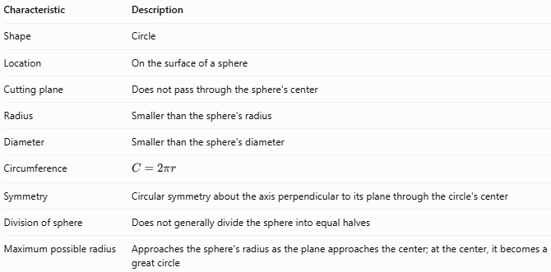
Characteristic | Description
Shape | Circle
Location | On the surface of a sphere
Cutting plane | Does not pass through the sphere's center
Radius | Smaller than the sphere's radius
Diameter | Smaller than the sphere's diameter
Circumference | $$C=2πr$$
Symmetry | Circular symmetry about the axis perpendicular to its plane through the circle's center
Division of sphere | Does not generally divide the sphere into equal halves
Maximum possible radius | Approaches the sphere's radius as the plane approaches the center; at the center, it becomes a great circle

Geometric Components
# Source: AI Source: Provided by: [Data Path: Persons Table -> ID Column: 1, Name_En Column: Motasem Essam] -> From: [ChatGPT] on [7/25/2026]
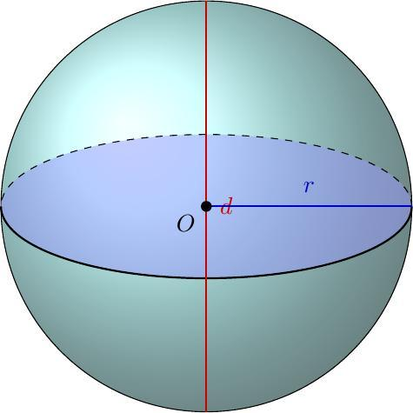
- Sphere: The three-dimensional solid containing the circular section.
- Small circle: The circular intersection between the sphere and an off-center plane.
- Sphere center ($O$): The center of the original sphere.
- Sphere radius ($R$): Distance from the sphere's center to its surface.
- Small-circle radius ($r$): Distance from the small circle's center to its circumference.
- Plane distance ($d$): Perpendicular distance from the sphere's center to the cutting plane.
- Small-circle center: The point where the perpendicular from the sphere's center meets the cutting plane.

Mathematical Representations and Formulas
# Source: AI Source: Provided by: [Data Path: Persons Table -> ID Column: 1, Name_En Column: Motasem Essam] -> From: [ChatGPT] on [7/25/2026]
Let:
- $R$ = radius of the sphere
- $r$ = radius of the small circle
- $d$ = perpendicular distance from the sphere's center to the cutting plane

Radius of a Small Circle
# Source: AI Source: Provided by: [Data Path: Persons Table -> ID Column: 1, Name_En Column: Motasem Essam] -> From: [ChatGPT] on [7/25/2026]
The sphere's radius, the small-circle radius, and the plane distance form a right triangle.
$$R^{2}=r^{2}+d^{2}$$
Rearranging:
$$\boxed{r=\sqrt{R^{2}-d^{2}}}$$
For a genuine small circle, $0<d<R$, so $r<R$.

Diameter
# Source: AI Source: Provided by: [Data Path: Persons Table -> ID Column: 1, Name_En Column: Motasem Essam] -> From: [ChatGPT] on [7/25/2026]
$$\boxed{D_{s}=2r}$$

Circumference
# Source: AI Source: Provided by: [Data Path: Persons Table -> ID Column: 1, Name_En Column: Motasem Essam] -> From: [ChatGPT] on [7/25/2026]
$$\boxed{C=2πr}$$
Substituting the radius formula:
$$\boxed{C=2π\sqrt{R^{2}-d^{2}}}$$

Area Enclosed by the Small Circle
# Source: AI Source: Provided by: [Data Path: Persons Table -> ID Column: 1, Name_En Column: Motasem Essam] -> From: [ChatGPT] on [7/25/2026]
The area of the circular disk in the cutting plane is:
$$\boxed{A=πr^{2}}$$
Using $r^{2}=R^{2}-d^{2}$:
$$\boxed{A=π\left(R^{2}-d^{2}\right)}$$
This is the area of the flat circular section, not the curved surface area of the sphere.

Relationship to the Great Circle
# Source: AI Source: Provided by: [Data Path: Persons Table -> ID Column: 1, Name_En Column: Motasem Essam] -> From: [ChatGPT] on [7/25/2026]
A great circle has radius $R$. A small circle has radius $r<R$.
$$\boxed{r<R}$$
As $d$ increases, the small-circle radius decreases. When the plane passes through the sphere's center, $d=0$, and the circle becomes a great circle.

Worked Examples
# Source: AI Source: Provided by: [Data Path: Persons Table -> ID Column: 1, Name_En Column: Motasem Essam] -> From: [ChatGPT] on [7/25/2026]
Example 1: Calculate the Small-Circle Radius
A sphere has radius $R=10\text{ cm}$. A plane cuts the sphere $6\text{ cm}$ from its center. Find the radius of the small circle.
Solution
$$r=\sqrt{R^{2}-d^{2}}$$
$$r=\sqrt{{10}^{2}-6^{2}}$$
$$r=\sqrt{100-36}$$
$$\boxed{r=8\text{ cm}}$$
Example 2: Calculate the Circumference
A small circle has radius $r=4\text{ cm}$. Find its circumference.
Solution
$$C=2πr$$
$$C=2π\left(4\right)$$
$$\boxed{C=8π\text{ cm}≈25.13\text{ cm}}$$
Example 3: Calculate the Circular Section's Area
A sphere has radius $R=13\text{ cm}$, and the cutting plane is $5\text{ cm}$ from the center. Find the area of the circular section.
Solution
First, calculate the small-circle radius:
$$r=\sqrt{{13}^{2}-5^{2}}$$
$$r=\sqrt{169-25}=\sqrt{144}=12\text{ cm}$$
Then calculate the area:
$$A=πr^{2}$$
$$\boxed{A=144π{\text{ cm}}^{2}≈452.39{\text{ cm}}^{2}}$$
Example 4: Calculate the Plane's Distance from the Center
A sphere has radius $R=10\text{ cm}$, and a small circle has radius $r=6\text{ cm}$. Find the distance between the center and the cutting plane.
Solution
$$d=\sqrt{R^{2}-r^{2}}$$
$$d=\sqrt{{10}^{2}-6^{2}}$$
$$d=\sqrt{64}$$
$$\boxed{d=8\text{ cm}}$$

Comparison with Related Concepts
# Source: AI Source: Provided by: [Data Path: Persons Table -> ID Column: 1, Name_En Column: Motasem Essam] -> From: [ChatGPT] on [7/25/2026]
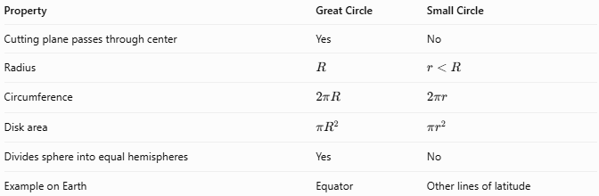
Property | Great Circle | Small Circle
Cutting plane passes through center | Yes | No
Radius | $$R$$ | $$r<R$$
Circumference | $$2πR$$ | $$2πr$$
Disk area | $$πR^{2}$$ | $$πr^{2}$$
Divides sphere into equal hemispheres | Yes | No
Example on Earth | Equator | Other lines of latitude

Applications
# Source: AI Source: Provided by: [Data Path: Persons Table -> ID Column: 1, Name_En Column: Motasem Essam] -> From: [ChatGPT] on [7/25/2026]
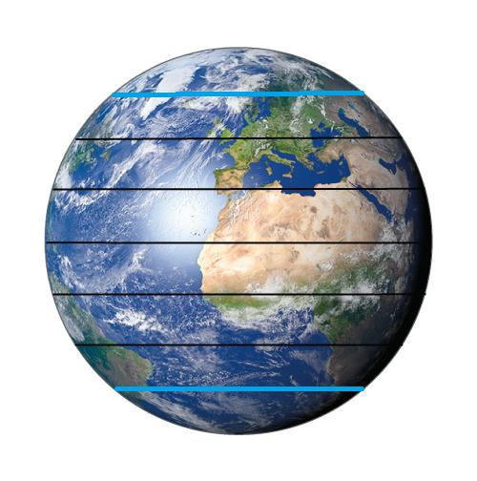
Geography
Lines of latitude other than the equator are small circles on an ideal spherical Earth.
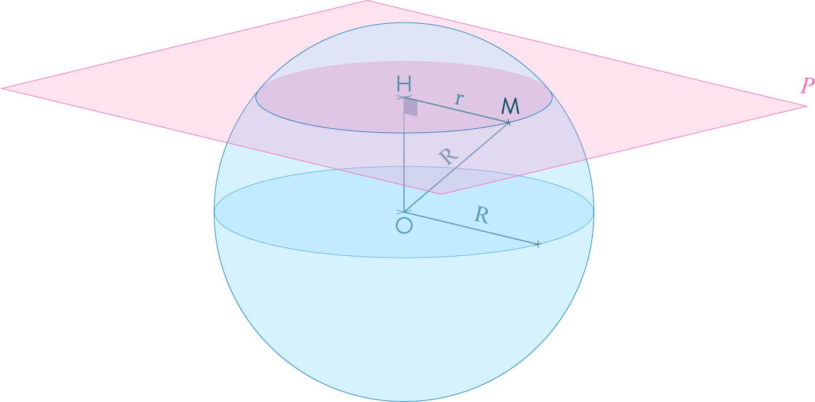
Solid Geometry
Small circles help explain how the radius of a circular section changes as a plane moves through a sphere.
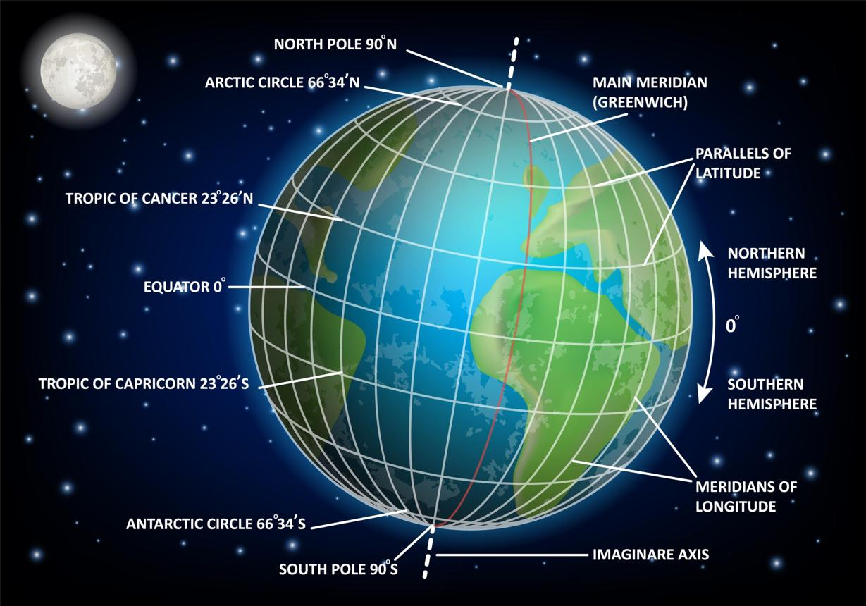
Geography and Astronomy
Circular sections are used to describe latitude bands and spherical coordinate systems.

Key Points to Remember
# Source: AI Source: Provided by: [Data Path: Persons Table -> ID Column: 1, Name_En Column: Motasem Essam] -> From: [ChatGPT] on [7/25/2026]
- A small circle is formed by a plane that does not pass through a sphere's center.
- Its radius is less than the sphere's radius.
- Its radius is $r=\sqrt{R^{2}-d^{2}}$.
- Its circumference is $C=2πr$.
- Its enclosed disk area is $A=πr^{2}$.
- Moving the cutting plane farther from the center makes the circle smaller.
- If the plane passes through the center, the section is a great circle instead.

Conclusion
# Source: AI Source: Provided by: [Data Path: Persons Table -> ID Column: 1, Name_En Column: Motasem Essam] -> From: [ChatGPT] on [7/25/2026]
A small circle is a circular section of a sphere produced by a plane that does not pass through the sphere's center. Its radius depends on the sphere's radius and the cutting plane's distance from the center. Small circles are important in spherical geometry and are commonly seen as lines of latitude on globes.

